JIGYASA PROGRAMME
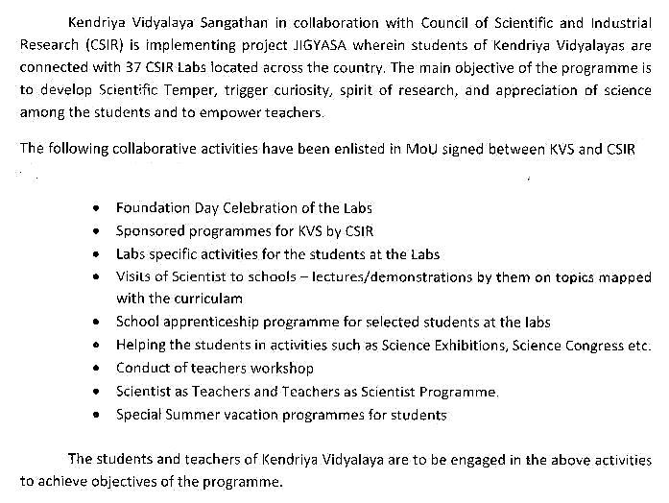

This programme is meant to trigger curiosity and research in field of science KVS is collaborating with CSIR for connecting 37 Central Labs with Kendriaya Vidyalaya. In this regard KVS Jabalpur Region has been connected with CSIR Lab Bhopal. Programme of activities has been approved by the director, CSIR Lab Bhopal and it has been circulated to all KVs in the region and according to the Progamme of activities all activities are taking place.

Summer Camp under Jigyasa programme was organised from 3rd May to 7th May in CSIR Bhopal in which selected 05 students one each from KV GCF No.1, KV Chhatarpur, KV Dhanpuri, KV 1 -STC, KV Damoh were participated. Next all programme/activities will be conducted as per the approved calendar of activities as given below.

